Myles of Great Hopes (MoGH) Donation Form
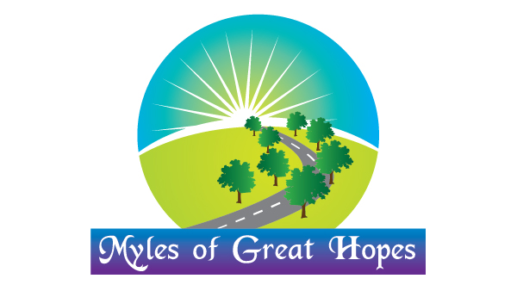

I would like to donate in support of the work Myles of Great Hopes is doing. I/We understand MoGH efforts are geared to Reviving, Empowering and Sustaining Hopes for the poor. The areas involved are Remote Communities projects, Education/schools and Churches.

Please fill this form and send together with your cheque/check. You can also process secure Pay Pal on our website, our address is:

Myles of Great Hopes
P.O. Box 934
Cary NC, 27512-0412

Please specify gift amount. (Tax deductable)

( ) $10,000 & up - Platinum ( ) $5,000 & up Gold ( ) $2,500 & up Silver ( ) $1,000 & up Bronze ( ) $500 Round Table ( ) $250 MoGH Mug ( ) $100 ( ) $50 ( ) $20
( ) Other amounts Please specify $__________________

With MoGH, We will recognize you by posting your link or logo to our website appropriately. If individual personal donation, we will honor your contribution in the best way you will prefer, including naming the project after you or your wishes.

Your Residency:

Name __________________________________________________________
Address __________________________________________________________
State/Zip __________________________________________________________
Telephone: Business ___________ Home ___________ Cell ____________
E-mail _________________________________
Optional service-
If you would like to donate as a gift in the honor or memory of someone, please list his/her name and his/her formal title ___________________________________________________

Please let us know whether to notify someone about your donation, include their name, address, email; and telephone number. This is to include your company for possible philanthropy match-up program
_____________________________________
_____________________________________
We thank you for your kind donations!
Myles of great hopes P.O. box 934, Cary NC, 27512-0412 Tel number: 919 602 4640. Web: www.mylesofgreathopes.org Email: mogh@mylesofgreathopes.org, Isaac.kuria@mylesofgreathopes.org

